UID EXPERIMENT-4

NAME: SHERIN KATHERINA D ROLL NO: 240701495

Screen 1: Welcome & Location Selection
This screen welcomes the user and allows them to choose a delivery location.

Familiar Icons:
- Scooter Icon – Delivery Service
  - Common symbol used in food delivery apps.
  - Helps users understand the app purpose quickly.
- Search Bar – Search Location
  - Used to enter address manually.
- Continue Button – Proceed
  - Helps users move to the next screen.

Unfamiliar Elements:
- Use My Current Location Feature
  - Uses GPS to detect location automatically.
  - May feel new for first-time users.

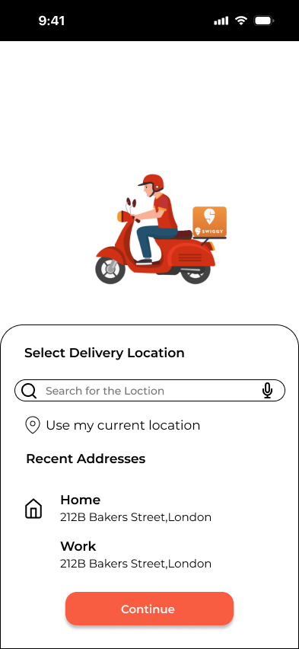

Screen 2: Home Page / Restaurant List
This screen displays restaurants and food offers.

Familiar Icons:
- Restaurant Logos – Brand Recognition
  - Helps users identify restaurants quickly.
- Star Icon – Ratings
  - Shows customer reviews and quality.
- Cart Icon – Shopping Cart
  - Used to view selected items.

Unfamiliar Elements:
- Top Banner Offers
  - Sliding promotional banners may confuse some users initially.

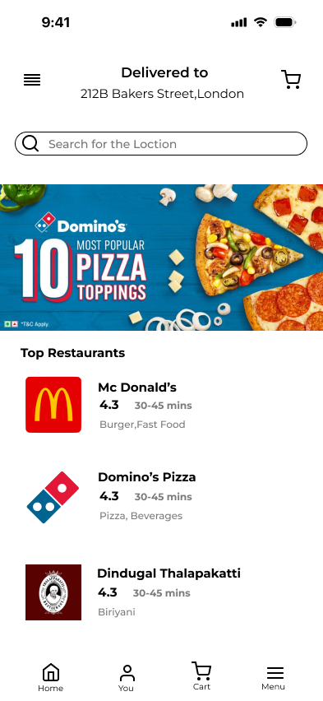

Screen 3: Food Item Details
This screen shows selected food item details and customization options.

Familiar Icons:
- Plus (+) Icon ➕ – Increase Quantity
  - Used to add more items.
- Minus (-) Icon ➖ – Decrease Quantity
  - Used to reduce quantity.
- Add to Cart Button
  - Adds selected food item to order list.

Unfamiliar Elements:
- Customization Section
  - Options like size, cheese, spice level, toppings may be new for some users.

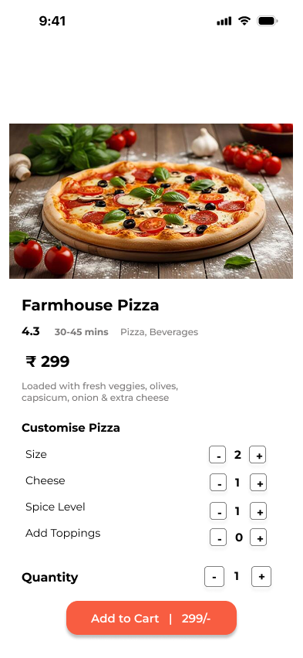

Screen 4: Checkout / Bill Details
This screen shows payment summary and order confirmation.

Familiar Icons:
- Bill Section – Price Details
  - Displays item cost, delivery fee, tax, and total.
- Confirm Order Button
  - Used to place final order.
- Quantity Controls (+ / -)
  - Adjust item quantity before payment.

Unfamiliar Elements:
- GST and Extra Charges Section
  - Some users may not understand tax calculations clearly.

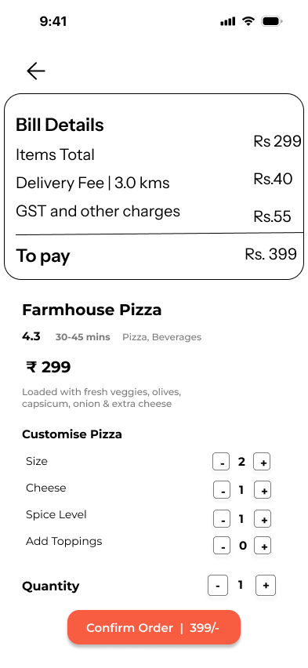

Ease of Use Evaluation

Young Users:
- Easily understand icons and navigation.
- Comfortable with customization and quick ordering.

Middle Age Users:
- Familiar with restaurant lists and payment flow.
- Need some guidance for offers and customization.

Elderly Users:
- Basic buttons easy to understand.
- GPS location and customization options may be confusing.

Conclusion
The Food Delivery App combines familiar navigation elements such as search bar, cart, ratings, and confirm button with unfamiliar features like GPS location detection, promotional banners, and food customization. Younger users adapt faster, while older users prefer simpler layouts with clear labels.

Prototype Link: https://www.figma.com/design/KO6m2ft9rRyUuICZXTd4QQ/Untitled?node-id=0-1&t=v6GDQKfdYKYTbq3k-1

